Hair Hurling ball, Knockmore Kilmihil 1971

In 1971 a hair hurling ball was found at a depth of about five feet in a bog fringing Lough More, about a mile northeast of the village.
The finder was Thomas Haugh of Knockmore and it was obtained for the Museum through the good offices of Mr Patrick Cotter, Knockbeg.
The ball is now at the Irish Folklife Division, National Museum of Ireland – Country Life, Turlough, Castlebar, Co. Mayo although it is not currently on display.

The ball was carbon dated between 1521 & 1578, another ball (in private ownership) was found in Kiltumper which would suggest that hurling must have been a pastime in Kilmihil parish at least as far back as the 16th century.

Knockmore ball
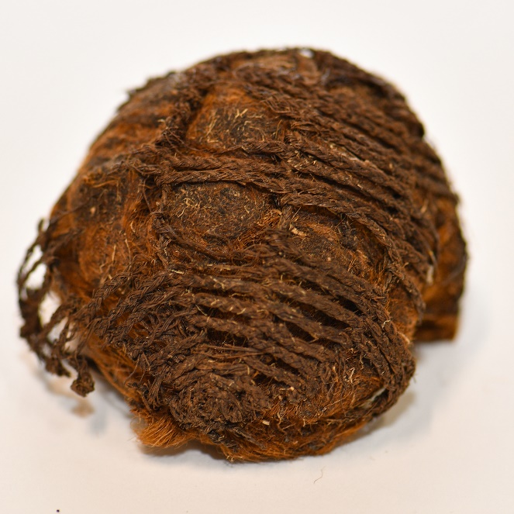

Kiltumper ball
